Cable TV
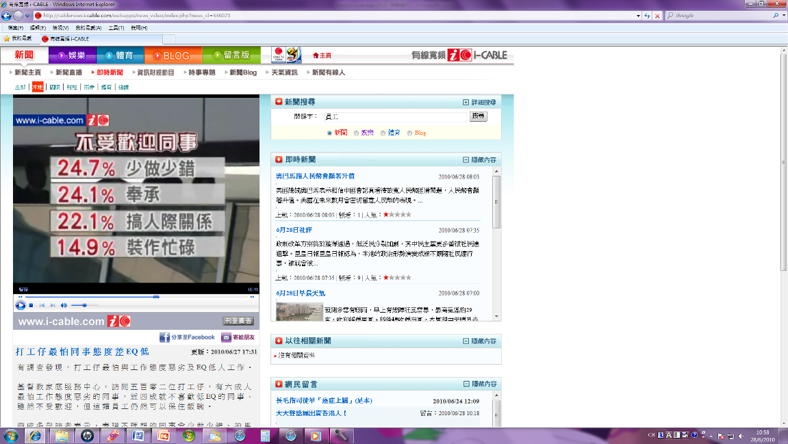
http://cablenews.i-cable.com/webapps/news_video/index.php?news_id=336025
TVB


Now TV


